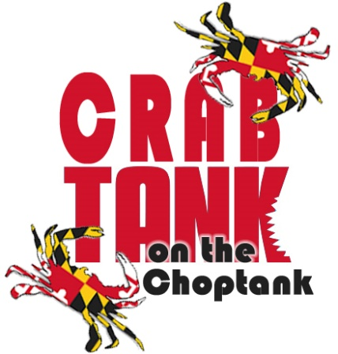
Pitch Competition

Purpose: To create an interactive opportunity at the Maryland Travel and Tourism Summit where a team brings their best ideas for bringing customers to Maryland in a pitch competition.

Background: Loosely based on pitch competitions such as Shark Tank. The contestants try to convince the crab (judges) to select a marketing platform for targeted consumers with specific interests that will drive overnight stays. The proposed idea should be ready for market by spring 2019. The proposed idea should not be in violation of any intellectual property rights, as far as you are aware, and will become the property of the Maryland Office of Tourism for promotion in conjunction with the award submission. The winning concept will be awarded $50,000 in promotional exposure that will be provided by OTD including a full-page ad in Destination Maryland, banner ads, and other outlets including but not limited to: newsletters, and visitmaryland.org website (There is no monetary or cash equivalent.)

Situational Analysis: Many of us in the tourism industry work in silos or with those products and people where there is a high level of comfort. This opportunity encourages cross-collaboration between county tourism offices, hotels, attractions and services to create programs and promotions that are targeted to four categories:

- Human Powered Recreation
- Family Travel
- Multicultural/Diversity Travel
- Group Travel

_____________________________________________________________________________________

Entry should include the information below:

Name/Team: ______________________________________________

Entry for which specific category: Please highlight or circle.
- Human Powered Recreation
- Family Travel
- Multi-cultural/Diversity Travel
- Group Travel

Provide a brief overview (no more than 100 words that includes target audience, geographic market, and main point of concept.)

If you have any questions, please contact: Liz Fitzsimmons at liz.fitzsimmons@maryland.gov

Entries should be submitted to Liz no later than October 15, 2018, and eligible proposals will be notified by October 19, 2018.

